Harefield Hospital
Department of Anaesthesia and Critical Care
Handbook 2022-23

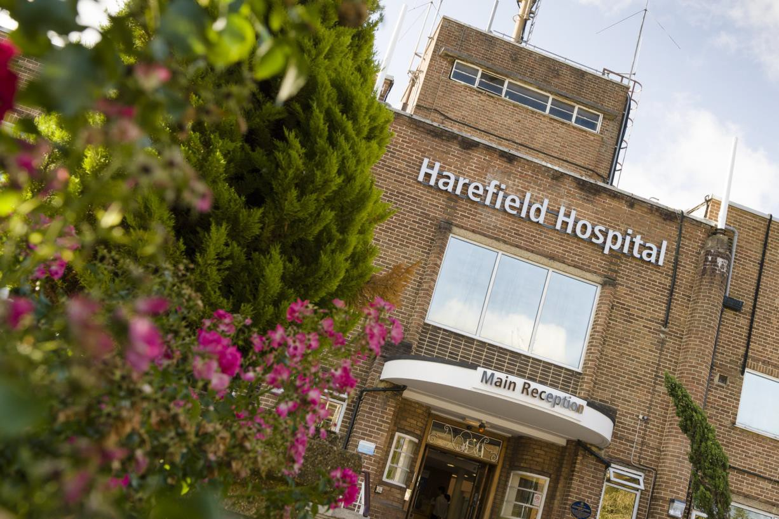

Contents
Welcome to Harefield Critical Care and Anaesthetics 3
General information 3
Some important Bleeps 4
Meet the Team 4
Rota, Annual leave and Study Leave 5
Study Leave for Deanery (training) Doctors 5
Study Leave for Trust Doctors (non-trainees) 6
Shifts and Duties 6
Rest and Refreshment Facilities 8
IT system: ICCA/MedChart 8
Critical Care Pharmacy Services 10
Postgraduate Education in Critical Care and Anaesthesia 12
Teaching and MDTs 12
Courses and Learning Resources 13
House Rules in ITU 13
Some Useful Protocols in Anaesthetics 15
Anaesthetic support in Percutaneous Coronary Interventions (PCI) 15
ICIP in Theatre - A Guide for the Perplexed 18
Cardiac anaesthesia 24
Temporary Pacing Boxes 27
Other Important Trust Protocols 30
Contributors 31

Welcome to Harefield Critical Care and Anaesthetics
Welcome to Critical Care and Anaesthetics at Harefield Hospital. This guide is deliberately short because it is simply not possible to create a comprehensive guide that can be tailored to junior doctors with varying critical care experience and skill sets. It sets out what happens in normal times. However, policies and procedures may alter during your stay in response to varying demands. Therefore we ask that junior doctors read all the updates communicated by email and ensure they are on all the relevant email lists (contact Caroline Brett if you are unsure).

This junior doctor guide is meant to be just that - a guide - and has been written by current juniors to give you an introduction to working in the Critical Care and Anaesthetic department at Harefield Hospital. However, it is not exhaustive and further information is available on the intranet and at your local induction. It is updated annually, but if you spot any errors, do let us know. For more general information about Harefield Hospital please refer to the Junior Doctor Handbook.

General information
There are five operating theatres in Harefield Hospital, and both Cardiac and Thoracic lists occur daily. The anaesthetic department provides anaesthetic support for theatres and regular cath lab lists, for EP procedures and device implantation, as well as “stand-by” anaesthetic cover for the cath labs for angioplasty.

The Intensive Therapy Unit (ITU) at Harefield Hospital has 24 beds, Recovery Unit has 7 beds and High Dependency Unit (HDU) has 10 beds. There are a further 4 level two beds on Juniper HDU which is located on the Private Patient ward. In these areas we care for a variety of cardiology, transplant and surgical patients. Patients are admitted to ITU from theatre, the primary angioplasty service and other hospitals. In addition to standard ITU support such as complex respiratory care and renal replacement therapies, we also care for patients requiring mechanical circulatory support (MCS) including:
- Extra corporeal membrane oxygenation (ECMO) – primarily VA ECMO
- Intra-aortic balloon pumps (IABP)
- Impella Devices
- Ventricular assist devices (VAD)
- Total Artificial Hearts (TAH)

The majority of patients stay on ICU for one to two days after their procedure, although those requiring ongoing support and intervention may stay longer. Patients are admitted to recovery from theatres; thoracic patients usually stay for a short time (typically a few hours), whilst cardiac patients (e.g. CABGs and valves) will generally stay in recovery overnight. Patients are typically stepped down from ICU to main HDU or Juniper HDU, except transplant patients who go to Rowan Ward. From there they will either step down to a level 1 ward (Maple / Cedar for cardiothoracic surgical patients, and Oak / Acorn for cardiology patients) or be repatriated to their referring hospitals for ongoing care. Those from recovery go to either HDU or a ward.

On ITU there are two consultant-led teams during the day and an SPR, SHO and consultant on-call at night. There is a consultant and SHO in Recovery during the day with an anaesthetic SPR covering at night. In HDU there is a consultant and SHO in the day and it is covered by the cardiothoracic SHO/SPR at night, with a consultant on call from home.

Some important Bleeps

Anaesthetic SPR: 6308*
ITU Outreach SPR: 6300*
ITU SPR: 6102*

Recovery SHO: 6084
HDU SHO: 6288

Outreach nurse: 6299
CTS SPR: 6103
Cardiology SPR: 6108
VAD team:
- Bleep: 6251
- Emergency: 07805768819
Heart Transplant SPR: 6186
Lung Transplant SPR: 6126
Radiographer on-call 6214
Radiologist: 85336

*Cardiac arrest bleep holders attend all cardiac arrest calls, CALS calls and shock calls. Note there are no medical emergency or peri-arrest calls at Harefield Hospital.

The rest of the numbers will be on the Induction App or via switch (dial 0)

.

Meet the Team

Consultants
Below are the Consultants in the anaesthetic and intensive care departments. Some cover both theatres and ITU; others are solely in the one area.

Theatres | Dr Francesca Caliandro – Deputy Director of Medical Education
Theatres | Dr John Farrimond
Theatres | Dr Andrew Gaunt
Theatres | Dr Ales Hodek – Cath Lab Lead
Theatres | Dr Katarina Lenartova – Acute Pain Lead
Theatres | Dr Simon Mattison – Director for Theatres, Lead for Recovery and Pre-op Assessment
Theatres | Dr Nandor Marczin
Theatres | Dr Sarka Moravcova (Echo Lead, theatres)
Theatres | Dr Marco Scaramuzzi – Theatre QI/Audit Liaison, Clinical Fellow Lead
Theatres | Dr Ben Silverman – RcoA College Tutor
Theatres | Dr Chris Skeoch
Theatres | Dr Alessandra Verzelloni
ITU and Theatres | Dr Caroline Bullen
ITU and Theatres | Dr Donna Hall – Cross-site ICU Lead
ITU and Theatres | Dr Orinta Kviatkovske
ITU and Theatres | Dr Nick Lees – Echo Lead (ICU)
ITU and Theatres | Dr Ian McGovern – Divisional Director HH
ITU and Theatres | Dr Sachin Mehta
ITU and Theatres | Dr Jerry Mitchell – Director if Anaesthesia and Critical Care & Lead in Clinical Risk
ITU | Dr Eftychia Galiatsou
ITU | Dr Clara Hernandez Caballero
ITU | Dr Ana Hurtado
ITU | Dr Sunny Kaul – Respiratory Physician and College Tutor to CMTs
ITU | Dr Alex Rosenberg – FICM Faculty Tutor and ICU Educational Lead
ITU | Dr Hatem Soliman

Administrators
Caroline Brett Lead Administrator
Directorate of Anaesthesia & Critical Care, HH
PA to lead Clinician Risk, HH
PA to Senior Nurse, Pain Management ,HH c.brett@rbht.nhs.uk

Rota, Annual leave and Study Leave

General Rules
- All annual leave and study leave must be booked with Caroline Brett 6 weeks in advance.
- All long days and nights must be swapped.
- All leave and swaps MUST be communicated with the rota co-ordinator.
- If you have booked time off please check the rota weekly to ensure that your name does not appear.
- Mandatory training is actually mandatory! Please ensure that you are booked on the sessions with our secretaries.
- Study Leave will not be issued unless mandatory training has been completed.

Rota
The rota is usually co-ordinated by one of the registrars and will be disseminated at the start of your placement. Finalised weekly rotas will be sent to all critical care staff by Caroline Brett c.brett@rbht.nhs.uk at the end of the preceding week.

Annual leave
You will be entitled to a number of annual leave days depending on your contract type. Generally, annual leave can be taken on standard ITU/anaesthetic days. If you would like to take HDU shifts, recovery shifts, long-days or night-shifts as annual leave, you will need to swap with a colleague who is on a standard day. Paper annual leave forms are in the anaesthetic office. After your annual leave is approved by the rota co-ordinator, please ensure you complete this form and send it to Caroline for the records. Similarly, if a swap has been arranged, you must also send an email to Caroline Brett so that accurate records may be kept. Any issues with the rota please contact the co-ordinator and/or your Educational Supervisor.

Study Leave for Deanery (training) Doctors
Study leave is allocated according to national HEE guidelines. Information about study leave may be found on the HEE website where there is also a list of mandatory and optional courses for your department. For approval of aspirational funding (which includes International claims) please contact your Training Programme Director (TPD). Initial payment should be made by the applicant and form, receipts and certificates submitted via email to meded@rbht.nhs.uk. All internal/core and higher trainees are entitled to claim up to 30 days of study leave per year. Trainees may apply for one international event per stage of training i.e. one in Foundation, one in core and one in higher training. Trainees on run- through programmes or established dual training programmes may apply every three years. Trainees will continue to apply via the established aspirational route. Trainees will receive either the cost of the event or the cost of economy travel and hotel accommodation to support attendance, whichever is the lower amount. These principles are now available as FAQs and trainees should be directed to the PGMDE support pages for further advice. For further information, please visit the PGME study leave page.

Study Leave for Trust Doctors (non-trainees)
Up to 10 days of Study Leave can be taken per year (more at the manager’s discretion). You must discuss your study leave application with your supervisor or clinical lead and obtain their approval. You then need to obtain approval from the rota co-ordinator, and then send a copy of the study leave application to Caroline Brett. Approval should be sought at least 6 weeks before leave. Paper study leave forms are in the anaesthetic office. Study budget may be applied for and granted at the management’s discretion. If approved, initial payment should be made by the applicant and the forms, receipts and certificates submitted via email to meded@rbht.nhs.uk. Re-imbursement of payment is made after the applicant has attended the course and all receipts have been received. For further information, please visit the PGME study leave page.

Sick leave
Sickness is unavoidable. If you are unfortunate enough to be unwell and are unable to attend work, you MUST do the following:
- Between 07:00 & 08:00 (as early as possible please)
  - Contact bleep 6102/6308 to tell them you are ill and unable to come in
  - Call the anaesthetic office on 01895 828946 & leave a message on the answer machine
- Call in on a daily basis to update us and let us know how you’re doing. This stops us worrying and means that we can plan ahead more easily.
- Inform occupational health if required (e.g. if you have symptoms of COVID-19, please see the intranet for further guidance)

Shifts and Duties

SHO / Junior Clinical Fellows (JCFs)
- Standard day ITU 8am-6pm: No Bleep. You will be with one of the two teams on ITU. The day starts in handover at 8am where the night team discuss patients on the unit. The handover is usually attended by the Transplant Medical team (who work on Rowan and Fir Tree) and the Transplant Surgeons, therefore patients with transplants and MCS are discussed first. There will be two consultant led ward rounds, in the morning and the afternoon. You will typically document the ward round on ICCA. After this you help to carry out the jobs such as liaising with other teams, attending MDTs, doing and observing procedures. Either you or the long day junior will update the patient list at the end of the day.
- Long day 8am-8pm: No bleep. There is usually a long day junior (SHO or SPR) on each team in ITU. They attend both handovers and update the night team about the events of the day. The shift is largely the same as a standard day but you stay in the evening to complete jobs, attend emergencies on the unit and update the list. There is no bleep for the long-day SHO.
- Recovery 8am-6pm: Bleep 6084 (at the nurse’s station in recovery). You will be with a consultant in Recovery. You will see all the patients in recovery on the morning ward round. You then review all the cardiac cases as they come out after theatre (i.e. as part of the “afternoon ward round”). The thoracic cases stay under the care of the anaesthetist doing that case, although the nurses may ask you for limited input in their care. At 6pm you hand over to the anaesthetic SPR on bleep 6308. There is no patient list in recovery. For more information see the Recovery Unit Guidelines in the H:Drive.
- HDU 8am-6pm: Bleep 6288 (at nurse’s station in HDU). You will be with a consultant in HDU. Handover is in the HDU staff room at 8:30am with the consultant, nurse-in-charge, therapists and bed manager. You will do two ward rounds in HDU;

one in the morning and one in the afternoon. You will also be looking after patients in Juniper HDU. At 6pm you handover to the cardiothoracic SPR on-call via bleep 6103. In HDU the nurses update and print the list for you.
- Night shift 8am-8pm: No bleep. There are two SPRs and one SHO at night. All patients are reviewed at least once overnight, and more than once if they are unstable. One SPR will hold a bleep for emergencies.

The ITU patient list should be updated and printed by the junior doctors prior to the morning and evening handovers. It is located on the shared drive: H:\H_Itu\Daily List so please ensure you have access to this. There is no list in Recovery or Juniper HDU. The nurses update and print the list in the main HDU.

ITU SPR / Senior Clinical Fellow (SCF)
- Standard day ITU 8am-6pm: No Bleep. You will be on one of the two teams on ITU. The day starts in handover at 8am where the night team will discuss patients on the unit. The handover is usually attended by the Transplant Medical team (who work on Rowan and Fir Tree) and the Transplant Surgeons, so patients with transplants and MCS are discussed first. There will be two consultant led ward rounds, one in the morning and one in the afternoon.
- Long day 8am-8pm: Bleeps 6102 (ITU SPR), 6300 (ITU Outreach). The shift is largely the same as a standard day but you will also carry the ITU and / or Outreach bleep depending on how many SPRs are rostered on the long day. Outreach bleep holder attends cardiac arrest calls, CALS calls and shock calls and also takes and reviews referrals on the wards.
- Night shift 8am-8pm: Bleep 6102 (ITU SPR). In ITU with an SHO covering the unit.

Anaesthetic SPR
- Standard day 7:30am-6pm: No Bleep. You will typically be in theatres on an allocated list. Trainees are expected to be in theatre with everything prepared when the patients arrive at the following times:
  - All Cardiac lists begin at 07:45.
  - All Thoracic lists begin at 08:00.
  - Cath Lab list start times are between 08:00 and 09:00.
- Long day 7:30am-8pm. Bleep 6308. You will be in theatre during day and also holding bleep 6308 for cardiac arrests, shock calls and CALS calls. You will also attend cath labs whenever anaesthetic cover is required and act as a back-up for recovery if necessary. Daily ward rounds of Recovery should be completed on weekends and Bank Holidays. At 16:00, the theatre on-call anaesthetic registrar will arrange for the theatre trainees to pre-assess patients for the following day. At 18:00 you take a handover from the recovery SHO. For more information see the Recovery Unit Guidelines in the H:Drive. The theatre on-call registrar must pre-assess patients over the weekend for theatre on Monday.
- Night 8pm-8am: Bleeps 6308 (Anaesthetic SPR) and 6300 (ITU outreach). The night Anaesthetic SPR covers theatre, recovery, cath labs, and the outreach bleep for all ward-to-ITU referrals. Both 6308 and 6300 are crash bleeps and you will attend cardiac arrests, shock calls and CALS calls. At the start of the shift you take handover from the critical care outreach nurses. A night on-call room is available in the paediatric department behind HDU; information about access can be obtained from Caroline Brett.

Scrubs, lockers and theatre shoes
Blue scrubs are worn in ITU and HDU and may be found in the ITU changing rooms and theatre changing rooms. Raspberry scrubs are worn in theatres, recovery and the theatre staff room and may be found in the theatre changing rooms. There are usually some unallocated lockers outside the changing rooms in ITU or you may ask for your own in the theatre changing rooms by contacting the theatre manager. There are theatre shoes available for visitors although it is recommended you purchase your own for the duration of your placement.

Rest and Refreshment Facilities
The ITU staff room is open to all critical care staff and has a fridge, kettle, coffee machine and chairs to relax in. There is also a lovely garden for use when the weather permits. The anaesthetic office has a quiet area with a couch and some computers. During night shifts there is an allocated on-call room for the anaesthetic SPR but unfortunately not one currently for the ITU SPR or SHO although they may use the office to rest (please remember it is a work space so must be kept clean and tidy). There are lockers available outside the ITU changing rooms and in the theatre changing rooms. There is also a Doctor’s Mess and various other staff rooms throughout the hospital; please see the Harefield Hospital JD Handbook for more information.

IT system: ICCA/MedChart
The main IT system we use for prescribing, observations, documentation and results in ITU, HDU, theatres and recovery is IntelliSpace Critical Care and Anesthesia (ICCA). You will be taught how to use this at induction. It is a very intuitive programme with links to other IT systems such as ICE, XERO and EPR. All medications are prescribed on this with the exception of immunosuppressants for transplant patients, which are prescribed by the Transplant Pharmacist or Transplant SPR. Any issues with immunosuppression (including non-therapeutic levels and problems with absorption of oral immunosuppression) are dealt with by the transplant team.

Ensure that drug prescribing happens promptly, particularly at night. There must be no ‘cutting and pasting’ of examination findings on ICCA. If the Medical Admission Form has been started for you in theatre, you must complete the form when the patient arrives on ICU/Recovery. This must include the VTE assessments and clinical examination findings.

When a patient steps down from any critical care area you will need to complete a discharge summary on ICCA. If a patient is stepping down to a level 1 ward (usually from HDU), you will need to transfer all their current medications to MedChart, which is the e-prescribing system they use on the wards. If the patient is going to ITU, Recovery or HDU, you do not need to transcribe the medications, since ICCA is used iiin these areas. Medchart must be updated prior to transfer. If a patient dies in critical care, please ensure a brief discharge summary, with the salient points, is completed on ICCA.

Obtaining access to prescribing on ICCA
Complete the training on Learn Now
- The link to the e-Learning “ICCA (Adults) (for medical staff, pharmacists and non- medical prescribers)” is https://learnnowrbht.co.uk/login/index.php
- You need to complete both the e-Learning and the walk through.
- If you do not have access to Learn Now please contact the Learning and Development Team

Gaining Access to ICCA
- At 3pm each day users who have completed the training in the previous 24 hours are added to ICCA by a member of the ICCA Pharmacy Team. Once set up by ICCA team, access the system using your trust username and password
- If you urgently need access, please email Pharmacy-ICCA@rbht.nhs.uk with a screenshot of your certificate.
- Users are added Monday to Friday

If you do not need to prescribe or you need urgent access out of hours, you can be given non-prescribing access to document and view only without completing the e-Learning:
- Out of hours by Clinical Engineering
- In hours by Pharmacy ICCA Team

Obtaining access to prescribing on MedChart
Complete the training on Learn Now
- Using the search bar use the terms ‘EPMA’ or ‘MedChart’ find the training on LearnNow: https://learnnowrbht.co.uk/login/index.php Ensure you access the correct training.
- Ensure that you complete all required parts to the training so that each module has a tick against it. An example is shown below:

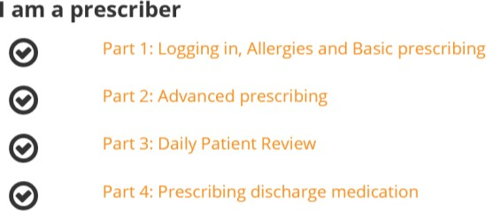

Gaining Access to MedChart
- Once you have completed Medchart EPMA training, the relevant training team will be able to update your account with your new access.
- The training team update the user accounts for staff who have completed their training in the previous 24 hours at 10:00am daily.

If you urgently require access to MedChart please take a screenshot of completed training and email it to the EPMA Team (EPMA_team@rbht.nhs.uk) who are available Monday – Friday

Critical Care Pharmacy Services

Pharmacy Hours
- Mon – Fri: 9 am- 5.15pm (Extension 85596)
- Saturday: 9am - 4.30pm (Critical care)
- Sunday: 10am -13.40pm (Critical Care)
- Out of hours: On call Pharmacist (non-resident) air call via switch board

Pharmacy team on Critical Care
- Two full time specialist pharmacists covering ITU, Recovery and HDU between them. Contactable on Bleep 6127 or Bleep 6422.
- The transplant pharmacists will look after the transplant and VAD patients (contactable on Bleep 6265).
- Provide 7-day clinical service at HH for Critical Care & Transplant/VAD patients

Critical Care pharmacists’ roles
- Attendance of daily ward rounds
- Critical care pharmacists are Non-Medical Prescribers and prescribe/adjust doses as discussed on ward rounds
- New drugs request/guideline development
- Compile Finance reports
- Complete Governance work
- Training and education (All clinical staff)
- Audits and Research project involvement

Automated Drug cabinets
ITU at HH has automated drug cabinets which is accessible by finger print log in. Pharmacy will set up login and training to access the medications from the Omnicell cabinet.

Prescribing
- All critical care drugs and infusions are prescribed on ICCA.
- Blood Products are prescribed on ICCA and the Blood Chart
- All drugs need to be transcribed on to MedChart for patients stepping down from critical care areas to Transplant/Cardiology/Surgical wards.
- Immunosuppressant medications are prescribed by the transplant team on MedChart for transplant patients on ITU and Recovery.
- Follow the national guidelines and local guidelines Medicines management - Intranet

Common Prescribing Protocols in Critical Care
Antimicrobials | Antimicrobial Prescribing Guide - Renal/Liver failure dosing of all drugs – refer to guide and/or consult ward pharmacist
Antimicrobials | Sepsis – empirical treatment  1st line:  - Tazocin (Piperacillin/Tazobactam) IV 4.5 every 8 hours (as Extended Abx Infusion over 4hours) plus  - Teicoplanin 400mg (6mg/kg if >70kg) every 12 hours for 3 doses then once daily OR Aminoglycoside (Gentamicin (5mg/kg), Tobramycin (5mg/kg) or Amikacin (15mg/kg)  2nd line:  - Meropenem IV 1g every 8 hours (as Extended Abx Infusion over 4hours) Plus  - Aminoglycoside as above or Teicoplanin 400mg (6mg/kg if  >70kg) every 12 hours for 3 doses then once daily thereafter

Penicillin Allergy:
- Ciprofloxacin IV 400mg every 12 hours plus
- Aminoglycoside as above plus or minus Teicoplanin
Peri-operative surgical guidelines
Cardiac Surgery (CABG/Valve Replacements and/or Repairs):
- Cefuroxime 1500mg IV at induction then 750mg before sternal closure, then 750mg 8 hourly for further 2 doses in Recovery/ITU (for total of 4 doses) plus
- Teicoplanin 400mg IV (6mg/kg if >70kg) at induction then 400mg 12 hours later (for 2 doses)
Penicillin Allergy:
- Teicoplanin IV 400mg (6mg/kg if >70kg) at induction then 400mg 12 hours later (for 2 doses) plus
- Gentamicin IV 2mg/kg ideal body weight at induction (single dose)
Antifungals
Antifungals: See Antimicrobial Prescribing Guide
- 1st line fluconazole – with loading dose 800mg then 400mg daily (PO or IV)
- 2nd line Caspofungin (Micro advice)
Stress Ulcer prophylaxis | - ITU patients are at an increased risk when mechanically ventilated >48hrs and multi organ failure.  - If patient on PPIs or H2 antagonist pre-op continue it on ITU.  - If not any PPI or H2 antagonist then use ranitidine and review at discharge. Continue in patients with additional risk factors e.g. high dose steroids or other risk factors i.e. renal failure, anti- coagulation  Refer to Stress Ulcer Prophylaxis guidelines for use in adult critical care
Anticoagulation & DVT prophylaxis | - DVT prophylaxis:  - Enoxaparin sc 40mg OD; Patient weight <50kg OD: 20mg; Patient weight >100kg 60mg OD  - Heparin sc 5000units bd (if on filter, severe renal impairment GFG <30ml/hr or SrCR >160)  - Systemic heparin:  - Indication to be endorsed on drug chart (e.g. AF, Mechanical Valve, VADs, TAH, ECMO, IABP, Impella Device) plus Target Xa-Level (usually aim for 0.3-0.5)  Refer to: Management of anticoagulation on Adult Critical Care
Bowel Management Guidelines | - Laxatives  - Routinely prescribed!!! Sodium docusate 200mg bd plus Senna 15mg OD.  - Suppositories prescribed regularly  - Add Movicol if BNO opened post 48-72 hours  - Prokinetics: If not absorbing use  - 1st Line: Metoclopramide 10mg TDS  - If not effective after 24 hrs add in iv Erythromycin 250mg bd (DO NOT USE in transplant patients – use azithromycin i/v or orally for Tx patients as second agent)  Refer to: Bowel Management guidelines for use in Adult Critical Care

Renal Replacement Therapies
Citrate filtration is the preferred option in our trust for all patients (including patients on systemic anticoagulation) except for patients with severe liver impairment. If citrate filtration not indicated/appropriate, then use continuous renal replacement therapy with no anticoagulation or anticoagulation with heparin. In general, the preferred modality used in the Trust is continuous veno-venous haemodiafiltration (CVVHDF), which combines diffusion and convective techniques. Refer to Guidelines for the use of Renal Replacement Therapies in Adult Critical Care

Resources for Critical Care

- Critical Care clinical guidelines
  - All reference guides can be accessed from ICCA via X Links:
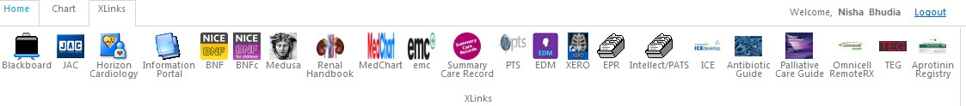
- Antimicrobial prescribing guide
  - Refer to: Antimicrobial Prescribing Guide
  - Can download micro guide available as free app on android/apple
- Heart failure and transplant prescribing guidelines
  - Refer to: Heart failure and Transplant Prescribing guidelines
  - Can download app: RBH transplant on android/apple
- The Renal Drug Handbook – from ICCA via X Links
- Minimum volumes guide
- Intravenous Drugs Compatibility chart (March 2015)
- BNF, Medusa & emc refer to: Medicines management - Intranet
- Medicines Advisory Service (Extension 88901)
- Your friendly pharmacist!!

Postgraduate Education in Critical Care and Anaesthesia
You will be allocated an Educational and Clinical supervisor. Please ensure you arrange meetings with them early on in the placement to plan your educational activities. The College/Faculty Tutors are there to help with any training issues, so get in touch if you have any concerns – Dr Ben Silverman (Consultant Anaesthetist, RCoA Tutor), Dr Alex Rosenberg (Consultant Intensivist, FICM Tutor), Dr Anthony Barron (Consultant Cardiologist, RCP Tutor).

Teaching and MDTs
There are regular teaching sessions and MDTs. They include:
- Physiology teaching: one hour per week, protected
- TOE teaching: one hour per week, protected
- Anaesthetic/perioperative teaching: one hour per week, protected
- Critical care Grand Rounds, weekly
- ICU journal club: one hour per week, protected (all juniors are expected to present at this so ensure you know what date you are allocated to)
- Academic afternoon on clinical governance day: third week of every month, protected – attendance is mandatory. Comprises the Grand Round at 9:00, followed by clinical audit, morbidity and mortality (M&M). In the afternoon of these “Audit” days there is compulsory teaching organised within the department.
- TOE simulation training sessions: quarterly – look out for the advert

Weekly ITU MDT, radiology and microbiology meetings are also held in critical care.

Courses and Learning Resources
As well as the regular departmental teaching, there are a number of local and regional courses which juniors may choose to attend. Study budget may be applied for – see the Harefield JD Handbook and policies on the intranet for more information.

In trust courses:
- FICE (focused intensive care Echocardiography)
- CALS course
- FEEL (focused echocardiography in emergency life support)
- Central venous catheter insertion course
- PICC insertion course
- Bronchoscopy Course
- ECMO course
- ICU Emergencies Course
- Transfer training

External courses:
- BASIC course
- e-learning intensive care medicine

House Rules in ITU

Covering ITU
- Please ensure that there is a doctor on ITU at all times. Do not all take lunch at the same time and do not take a rest period on nights at the same time.
- If you leave the unit please ensure that you carry your bleep with you at all times. Do not rely on mobile phone reception.
- If leaving the unit for a rest period, please ensure that the nurse-in-charge is aware of this as decisions may be needed to be taken before you leave to ensure that you get a reasonable time to rest.

New Admissions, RRT and patient deterioration
- Please ensure that the Consultant Intensivist is informed of all new admissions, of a decision to start renal replacement therapy (RRT) and any new deterioration in any patient (e.g. oliguria, reduction in cardiac output, significant increase in vasoconstrictors or inotropes).
- The Outreach Bleep holder (6300) must respond to calls in a timely manner. Patients at Harefield can deteriorate very rapidly.
- Please ensure that all drugs are brought back with you on patient transfer (e.g. to CT scan)
- External Referrals to Harefield Critical Care (i.e. from other hospitals) are via the referapatient.org platform. ITU consultants and the nurse-in-charge will receive notifications about incoming referrals. If the duty ITU SPR gets a phone call about a referral (e.g. if it is urgent or there was no response to their initial referral) please contact the duty consultant.

Communication
- Introduce yourself to all patients (as appropriate).
- On ward rounds, after each patient review, ensure patients are informed (as appropriate) of their plan of care for the day etc.

- Clarify with patients what has been said previously and that they understood their plan of care.
- Ensure nurses are involved in the ward round and are clear of the plan of care. Nurses can then also explain this to the patient.
- Ensure side rooms are entered during ward rounds but keep numbers of staff going into side rooms to a minimum.
- Please ensure that all new instructions from visiting consultants are communicated to the intensivist before changing patient management.

General
- Please exercise some common sense on nights, if a patient is stable, asleep and is of no clinical concern, please do not wake them up to examine them.
- Please refrain from riding the COWs. They are difficult to steer and have previously caused injury.
- Handover sheets must not be left lying around and must not leave the premises. They must be disposed of in the confidential waste bins - not the recycling!
- Please refrain from excessive mobile phone usage.
- Please do not leave empty dirty coffee cups around the ICU, in the tea room or in the anaesthetic office.
- Please do not expect Caroline and Alison to clear up after you in the anaesthetic office.
- If a patient dies in ITU / HDU / Recovery a discharge summary will need to be completed on ICCA and a junior doctor will need to fill out their death certificate (+ / - cremation form and coroners referral) in the PALS office as early as possible. Please refer to the Harefield Hospital JD Handbook for more details.

Some Useful Protocols in Anaesthetics

Anaesthetic support in Percutaneous Coronary Interventions (PCI)
Patients presenting with acute myocardial infarctions via the primary angioplasty service usually tolerate PCI well. However, they can occasionally develop low cardiac output states and acute arrhythmias (the latter being both as a consequence of the infarction process itself and also upon reperfusion of occluded vessels). In these circumstances, support from anaesthesia and intensive care is required.

Please ensure that you have had a formal tour of the catheter labs at trust induction, which should include lab numbers, location of lead aprons, anaesthetic machines, difficult airway trolley and fridges for emergency drugs.

Immediate Actions
- Notification will be via 6102 (ICU) and 6308 (anaesthetic) fast bleep to the relevant lab or via a “shock call” which will go to both bleeps.
- Remember to Bleep 6067 for ODP / ICU nurse support.
- First put on lead apron and thyroid shield, there is a supply for our department situated in the link corridor between theatres and cath labs. If these are unavailable or the wrong size, there is an additional store between labs 5 & 6.
- Upon entering room, please introduce yourself to the group. A white board will have relevant personnel written on it.
- A handover from the attending consultant cardiologist must be given at this time.

Team in Catheter Suite
- Consultant Cardiologist
- On-call cardiology SPR + SHO
- Cardiac physiologist
- Radiographer

- Scrubbed nurse
- Running nurse
- Health Care Assistant

Support
- ODP on site Monday - Friday 24 hour cover & weekend nights, Bleep 6067 (on PCI call list)
- At time of writing, there is no guaranteed ODP on site for Saturday and Sunday 08:00-20:00. During this time, the 6067 bleep will be carried by either the ITU, or outreach nurse, who will come and assist with initial management.
- If the case is prolonged or complex, the on-call ODP should be called in from home via switchboard, this can take 30 minutes.
- Any concerns call intensive care or anaesthetic consultant.

General Principles
- Communicate with the team often, particularly the situation regarding haemodynamics and oxygenation.
- The Cardiologists will be concerned with re-opening of vessels and you may be in the best position to note and act on changes.

Airway and Breathing
- Emergency drugs are in sealed white box in fridges in every lab.
- Etomidate and rocuronium first line drugs for intubation, not propofol.

- Cardiac arrest intubation usually self-evident. The challenge is more often than not, the agitated, uncooperative patient with threatened airway. If in doubt, sedate and intubate.
- Communicate with cardiologist as these are not easy patients to manage.
- Consider small aliquots of propofol (10-20mg only), midazolam (1-2mg), fentanyl (50
- 100mcg), or low concentration, inhaled sevoflurane if tolerated.
- Intubation should always be by rapid sequence induction.

Circulation
- Use non-invasive BP monitoring.
- Arterial access will always be performed by cardiologist as part of PCI procedure
  - Historically femoral, now mostly radial
  - Be aware that invasive BP is intermittently suspended during procedure (‘O- ring open’), so use NIBP
- Intra-venous access usually peripheral - check if large bore 14-16G needed
- Peripheral line should have extension line attached
- Consider setting up peripheral I.V. fluids with extension set, to avoid unnecessary risk of irradiation
- Central venous access maybe required for CVP measurement and administration of inotropes
  - Femoral access by interventionist safest and quickest method, using sterile extension lines for infusions
  - Remember, all patients will be acutely anticoagulated (usually with PO or IV), aspirin, plus ticagrelor (occasionally clopidogrel by paramedics). Heparin is given by cardiologist 5-10,000 units to maintain an Activated Clotting Time (ACT) of around 200 sec. Abciximab may be used in cases where anticoagulation is in doubt.

Inotropes/vasopressors
- Do use metaraminol 0.25-1mg boluses as emergency recovery of blood pressure
- There is no right answer regarding inotrope/pressor choice for persistent low blood pressure. Consider and discuss with consultant:
  - Adrenaline (4mg/50ml N/sal) 0.01-0.1mcg/Kg/min, especially if ventricular function impaired on TTE
  - Noradrenaline (4mg/50ml N/sal) 0.01-0.1mcg/Kg/min, if SIRS type pattern

Resuscitation
  - The LUCAS device ensures safe chest compressions to continue during X-ray screening and has an established role in management of cardiac arrest
  - It may interfere with ventilation and thus may require short periods of cessation
  - Check position of suction cup in centre of chest as injuries from too high and too low a placement can both occur.

Cooling (in ROSC OOHCA patients or those who arrest in cat lab)
  - For OOHCA patients who arrive via the PPCI pathway, the current protocol is for cooling to 34°C ideally initiated within 1 hour of ROSC.
  - Cool flow catheters are usually inserted by cardiologists prior to transfer to ICU.
  - The patient is cooled for 24-48 hours in ITU .

Post-procedure Management
  - Majority of patients will require intensive care management, hence the nurse in charge should be informed early
  - If there no beds, liaise with ICU consultant at earliest opportunity

  - If situation improves and you are no longer needed, please do confirm with team that it is safe and okay to leave.
  - Inform ODP or catheter staff if stock items all exhausted during case as they will need replenishing.

Final tips
  - ** If in doubt, call for senior support ** There is a consultant on call for both ICU and theatres, and one or both may already be in the hospital and able to help.
  - Do try to attend CRiSSIS during your time at Harefield. They are MDT in situ simulation sessions run by the cath lab team and are designed specifically to assist and familiarise staff in learning how best to manage these difficult patients. Notification will be via your trust email address.

ICCA in Theatre - A Guide for the Perplexed
  - To log on to the ICCA terminals in theatre, either use your normal computer log in or use the default username cvuser, with the password Brompton1
  - The patient should be allocated to the relevant anaesthetic room or theatre. They will normally be found on theatre page, under ‘no bed’ and can be dragged to correct slot.
  - If they are not on file (e.g. acute admissions), admit the patient onto the system by double clicking on your anaesthetic room and entering the required details: name and hospital number.
  - Click on ADT and fill in the red starred fields - height, weight, patient category (theatre/anaesthetics) and allergies must be entered, do not enter DOB. Without weight added, no infusion data requiring weight can be stored.
  - Prescribe some drugs - the HH anaesthesia order set will have most of what you need initially. Untick any drugs you won’t need before saving. Any drugs you require which are not in the set e.g. inotropes, blood products, aprotinin can be prescribed at your leisure once in theatre, in the same way that you would normally.
  - Click on flowsheet then the add rows icon, select row families and add invasive GA Aestiva and cardiac rows. This is the minimum you will need, other rows e.g. cardiac output monitoring and NO can be added according to the complexity of the case.
  - Save at this point.
  - Click on the Auto Chart icon and set to 5 minutes.
  - It is now safe to approach the patient - all routine observations will be automatically recorded from now.
  - Once you have finished in the anaesthetic room, click on the close chart icon and drag your patient from the anaesthetic room space to the theatre space.
  - Open up your patient in theatre, make sure you are in flowsheet anaesthetic and reselect auto-chart 5 minutes. All basic observations including details of ventilation and any blood gases will be recorded automatically. Other information requires manual input.
  - Fill in details of induction.
  - Each time a drug is given, click on medications and fill in details. Any drugs given by the perfusionists on bypass will be filled in by them, but must be prescribed by us first including cardioplegics.
  - Input fluid type and volume under intake don’t worry about rate of Infusion.
  - Input urine volume under output.
  - For continuous infusions, fill in all the available details including setting the initial volume to zero and telling it to start which is the bottom option. It will then assume that the infusion continues at the same rate. To repeatedly chart the infusion, single click in the subsequent empty boxes, the computer should automatically fill in the same details. To accept the values, click on the icon with the 3 ticks. If the infusion changes, double click and change accordingly. Only input volume once.
  - For cardiac output measurements, you only need to chart the actual output - cardiac index, SVR etc. will follow automatically.
  - NO (nitric oxide) ppm must be added manually.
  - To add ACT there is a blank box at the bottom of the blood gases.
  - To note particular events e.g. start of case, click on events cardiac and select accordingly, all events related to CPB will be filled in by the Perfusionists, don’t replicate these it will cause confusion.

  - When prescribing post-op drugs select the ICU admission order set according to whether the operation included CABG or not and discontinue any drugs that will not be needed on ICU.
  - At the end of the case, close the chart and drag your patient to ITU/Rec (not literally.)

Guide to ICCA set up in theatres:
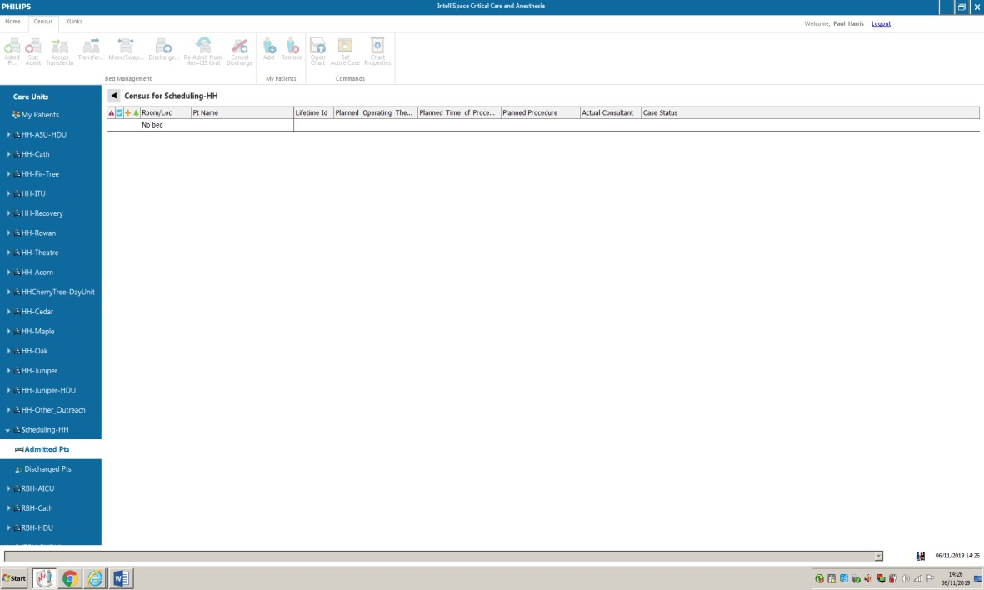
Above screen appears on logging in. Find the relevant destination – usually HH theatres
(circled) but may be cath lab. Remember ICCA used in ICU and all HDU areas (main HDU and Juniper HDU) thus if patient already on system, you can drag and drop them from that location to where they are going to.
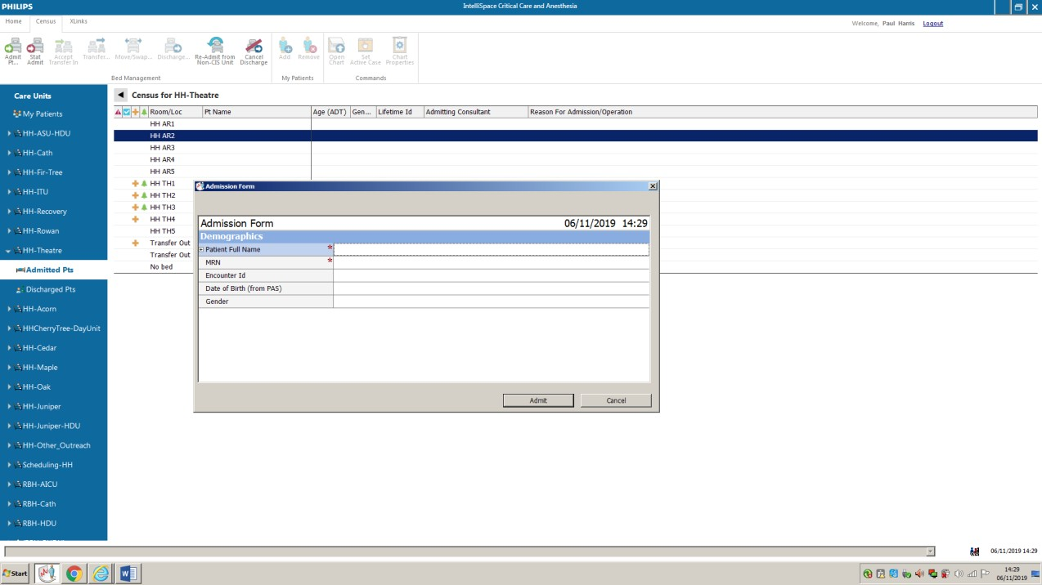
For a new patient, double click the empty box in the relevant anaesthetic room or theatre that the patient is going into. Fill in just patient name and hospital number. If they are already on ICCA at another location it will tell you so not possible to duplicate.

Three things required to do once patient selected to relevant destination:
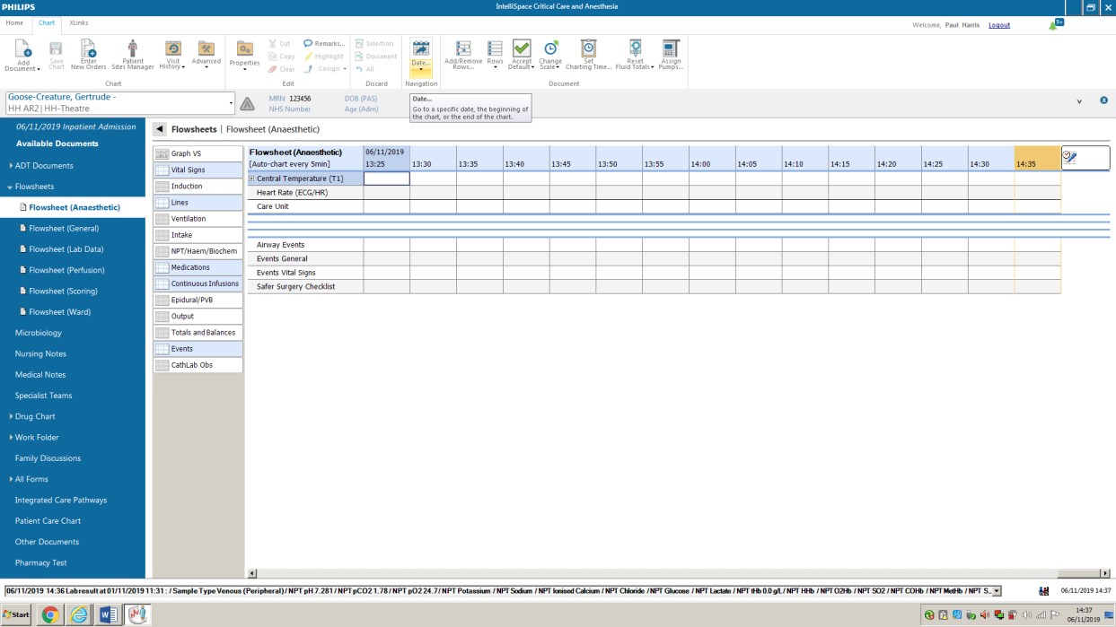

Enter new orders:
  - Should default to Direct Physician Entry
  - Under row 1, select Order Sets then highlight either Anaesthesia Cardiac or Anaesthesia Non-Cardiac surgery
  - Deselect drugs that are not required (cardiac list much more comprehensive than non-cardiac)
  - A couple e.g. cis-atracurium require a manual dose entry

Advanced:
  - Set chart time to 5 minutes

Add/Remove Rows:
  - Select Families
  - Choose GA Aestiva invasive or non-invasive depending on monitoring
  - Add appropriate other rows e.g. cardiac / thoracic / TOE / PA catheter as appropriate (see below picture)
Everything is now set up for starting either a thoracic or cardiac case.

Other things to remember:
- On left hand side of screen, open ADT documents, where you can add the patient’s weight, height and allergies.
- Select Patient Category/Formulary type as Adult Theatres/Anaesthetics.
- If the patient is already on ICCA use this record and don’t create another as it creates constraints on drug doses e.g. heparin
- With infusions, remember to document them, and put down ml given as zero, then START in drop down box. ICIP will then calculate thereafter avoiding manual input every 5 minutes. Note - if you don’t record Propofol and there is a case of awareness we have no evidence that it was running.
- Blood products are often easier to document after prescribing by clicking Drug Chart on left hand of screen then clicking in relevant box

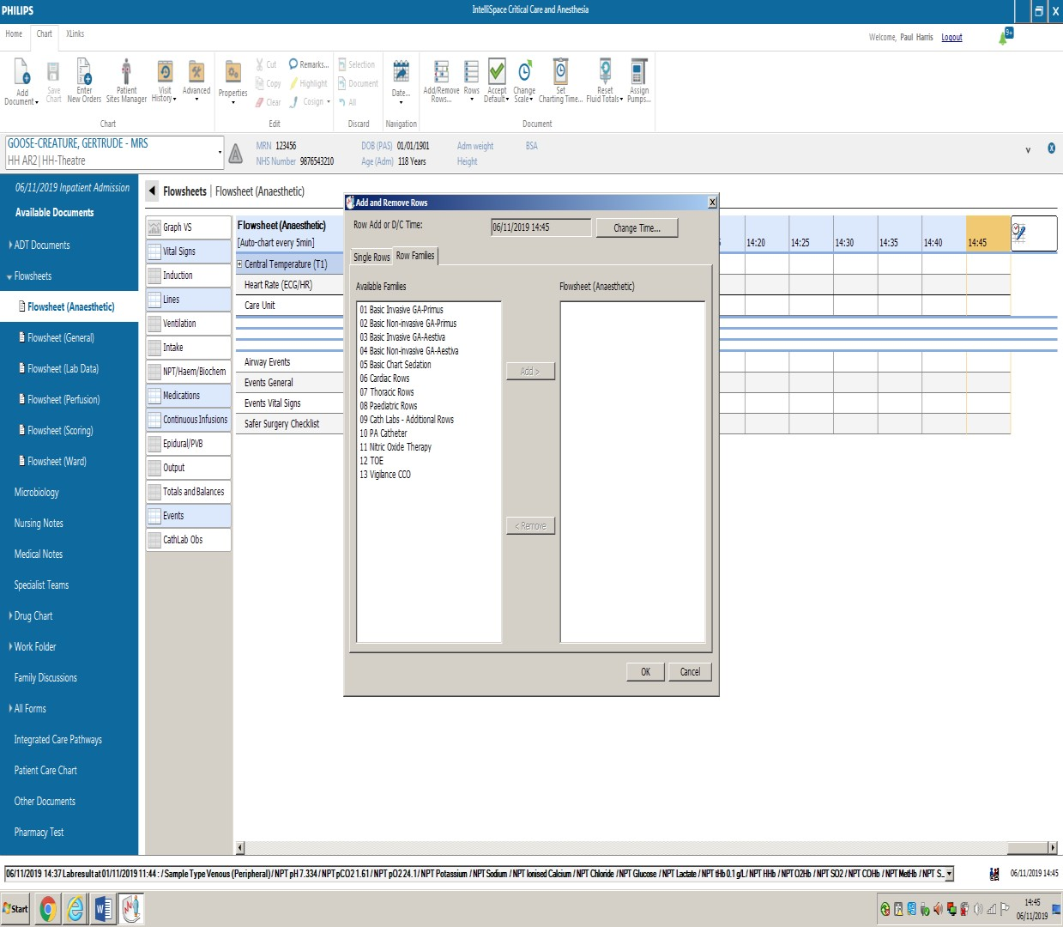
For transfer, three forms must be downloaded and saved from the Add Documents Box, top left of screen. These are:
- Anaesthetic Summary (from Medical notes section)
- ECHO report (from Medical notes section) – only if TOE used
- Medical Admission Notes (from Documents from other care units)
All of these require some filling in, although if the patient is not staying in an ICCA ICU/HDU area after, it is acceptable just to use the paper anaesthetic chart. Every form has some mandatory fields that prevent you leaving without saving. At the end of the case drag the patient record to the appropriate post-operative area (e.g. recovery, ITU).

Remember - if in doubt, revert to paper!

The Cardiac Patient Pre-Operative Assessment
Remember, all cardiac patients are high risk. Do not assume that somebody is fit for surgery simply because they have appeared on the list for the next day!

The expectation
- All elective patients will have been seen by a pre-assessment nurse, who should have flagged up particular issues requiring further investigation and then follow up on them. The commonest of these issues include:
  - Anaemia of unknown cause.
  - Reduced eGFR.
  - Poor respiratory function tests (RFTs).
- Pre-assessment result and a Euroscore II calculation should be on EPR.
- Pre-optimisation is vital to improve survival.

The reality
- We have lots of urgent transfers from other hospitals e.g. acute heart failures, post MI, that require surgery but where the referring hospital has been economical with the truth, thus they are transferred with many ongoing issues and often incomplete clinical documentation.
- These transfers miss the pre-assessment process.
- Private patients (ridiculously) do not go through the pre-assessment programme, nor do VAD patients or urgent cases.

Remember to allocate sufficient time - the cardiac pre-operative assessment is NOT a 5 minute assessment, as with other surgery.

Assessment
- System by system assessment of co-morbidities
- Examination and investigations
- Discussion of anaesthetic and ICU course of events

System by System Assessment
Cardiac | - TTE: All patients should have had an echo  - Ejection fraction (>60) useful number but is very reliant on initial length measurements and suffers from exponential error  - Mildly reduced EF in the presence of severe MR means ventricle is impaired (since some of the blood is going backwards)!  - Key things on TTE:  - LV / RV systolic assessment  - AR is a contra-indication to IABP (balloon)  - Valves – degree of leakage / stenosis  - PA pressures (usually calculated using jet of tricuspid regurgitation)  - Angiogram: Result often tricky to find in notes and does not appear on EPR  - Look for left main stem disease as they can be very unstable during anaesthetic  - Other: MRI / CT / nucleotide perfusion scans add weight to ventricular assessment

 | o ECG: AF / LVH
 | •
Respiratory | - PFTS: All elective patient should have PFTs. We hope to get lung dept do reversibility tests on all those with obstructive PFTS. Severe abnormalities usually see a chest physician, but occasionally missed. Use your judgement if poor PFTs overlooked (may benefit from course of nebs pre-surgery)  - Poor PFTS should have led to a CT chest
Renal | - eGFR using Cockroft-Gault. (Weight can reliably be found on EPR with lung function tests.) If GFR< 50, ask why? They should have been seen by renal team or had renal USS. Remember renal artery stenosis. GFR often on EPR results  - Prostate symptoms: Warns of possibility of failed catheter / suprapubic
CNS | - Previous CVA patients should have had CT head
Peripheral | - Carotids: all elective patients should have carotid Doppler although only symptomatic cases will be considered for CEA even if disease severe.  o ** Presence of subclavian stenosis is a contra-indication to LIMA-LAD grafting (look it up!) – and may be missed  - Femoral disease may influence cannulation and make IABP impossible
Bloods | - Anaemia – should have iron studies. Undiagnosed reason for Fe- deficiency anaemia risks exsanguination with heparin for bypass  - Low platelets should have haematology involvement (usually Dr Cummins)  - RV dysfunction causes liver engorgement – look for poor LFTs and clotting  - Albumin useful crude marker of pre-operative fitness
Redo Cases | - Should all have had a CT chest to look at underlying structures!!  - Remember redo defib pads for all redo cases in theatre
Drugs | - AII antagonists stopped as per usual, no diuretics day of surgery
Scoring Systems | - Euroscore II now used and is free on line (on EPR by pre- assessment nurses)

Examination
  - Huge array of clinical signs
  - Don’t forget to look at CXR – all sorts of unexpected findings appear and we are all bad at looking. Embarrassing if huge mass that nobody has noticed!

The discussion
  - Discuss risk on individual basis, using information from above.
  - Try to reassure the good LV, non-IDDM, good PFT, good renal function patients that they are in a very low risk bracket
  - Consent should include GA, neck lines, TOE (+ risk of oesophageal injury), catheter
  - Also discuss ICU, usually for 24 hrs but occasionally prolonged (particularly poor PFTs and low GFR – discuss CVVHF).
  - Lower risk patients go to Recovery, higher risk to ICU.

  - Discuss bleeding and risk of blood transfusion, Re-opening quoted as 20%
  - Most patients go to ICU under light GA and are awoken when following criteria are met:
    - Good BP
    - Breathing well with minimal ventilator support
    - Warm
    - Comfortable
    - Passing urine
  - Tailor explanation of a longer ICU stay based on the prediction of problems with any of the above 5 tick boxes.
  - Low risk patients should expect to go home in 5-7 days depending on age etc.

Anaesthetic Chart
Please fill in the height and weight (vital for perfusion and infusions). Also, please remember to sign & print your name (legibly!) – it gets forgotten all the time.

Transplant Cases
All will have had thorough work up, often very nicely summarised on EPR but important anaesthetic issues e.g. airway will have been completely overlooked

Heart Failure VAD cases
Patients who are too sick for transplant but often with no pre-op assessment – the ultimate challenge using your new skills!

If in doubt ring the consultant, don’t just document finding then ignore!

Cardiac anaesthesia

Preparation
- Draw up drugs – consultant preferences in folders in each anaesthetic room
- Upload patient onto ICCA:
  - Drag patient from ward area / non-bed etc. or double click appropriate anaesthetic room to insert name and hospital number only (it will tell you if record already exists)
  - In Advanced, set auto-charting to 5 minutes
  - Under Add Rows – Add appropriate Family i.e. Aestiva GA Invasive, plus appropriate additions e.g. TOE, PA monitoring, iNO etc.
  - Prescribe – Order Sets – cardiac – deselect drugs not being used
- Check both anaesthetic machines
- Turn on TOE machine and enter patient details

Patient arrival
- Assist transfer to operating table as you normally would, remembering patient may have had pre-medication
- Slip patient arms from gown, ensure bed plugged in (warmer blanket beneath)

Anaesthetic room
- Insert an arterial line – normally right radial – remember to ensure surgeons have not requested radial artery for grafts, use copious local anaesthetic and massage in.
- Obtain ACT and baseline ABG from arterial line.
- IV access – small, pre-existing peripheral usually sufficient, then usually insert a 14G peripheral post-induction.
- Induction – pre-oxygenation, trainee normally at head end.

- Intubation – move ETT behind tongue, to left to aid TOE insertion later.
- Think minimal access – double lumen tube? Lines on side of surgery?
- Central access- norm is RIJ CVC (5) +/- PA sheath, leave top of dressing on to avoid being pulled off at end of surgery with drapes.
- Thermometer (nasal), tape eyes +/- foil hat
- Urinary catheter, ensure urine using Instillagel syringe, pre balloon inflation.
- Think: reposition defibrillator pads, INVOS, BIS if necessary.
- Ensure arms wrapped at side, three-taps and venflon caps wrapped, diathermy pad appropriately applied.

Theatre - before KTS
- Transfer patient into theatre and drag ICCA record into correct theatre.
- Connect to ventilator, PEEP, connect ETCO2, isoflurane default vapour – ensure anaesthesia maintained.
- Connect infusions to appropriate CVC ports (ask!) and label correctly.
- Flush and connect Fluido fluid warmer to appropriate large bore IV access.
- Warming: Bair Hugger, bed under-heater, fluid warmer.
- TOE insertion, use lube +/- mouth guard.
- Ensure monitoring all connected.
- Consider extra fentanyl analgesia pre-KTS.
- If aprotinin is used, 1ml test dose is required several minutes before the full dose.

Theatre - after KTS
- Lungs disconnected for sternotomy – ideally not hypertensive (subjective). Hold tubing to avoid forgetting re-ventilation.
- Connect internal defib and test with scrub nurse (unless redo, then connect external pads to machine).
- Watch order of surgical procedures – CABG usually LIMA harvest (10-30min, maybe bilateral), for valves, surgeons may request heparin within minutes of KTS
- HEPARIN: Off pump dose 200U/Kg, On pump dose 300-400U/Kg, test ACT after 3 minutes.
- ACT should be >400 for bypass, but if close to that number, 5,000U heparin often given.
- Aortic cannulation – use GTN boluses 0.1ml to have SBP <100mmHg. Line dead space 0.7ml.
- Listen for perfusionist confirmation of good swing on arterial cannulation – they can give volume.
- FiO2 1.0 post aortic cannulation, until on CPB.

Going on cardiopulmonary bypass:
  - Anaesthesia – propofol infusion (as per instruction 20+ml/hr), maybe isoflurane on pump, maybe midazolam / fentanyl / muscle relaxant bolus,
?BIS.
  - Transfer ETCO2 line to perfusionist.
  - Stop IV fluids and non-essential infusions (ask advice).
  - Empty urinary catheter.
  - Metaraminol to perfusionist (ensure enough).
  - Lungs off only when perfusionist confirms Full Flow. Change monitor to CPB ( Fast Access button-OR- Bypass on) & turn off sats beeps.

On Bypass
  - ICIP documentation:
    - Medical admission note
    - Anaesthetic Summary
    - TOE Report

    - Post-operative drug order sets (only difference between CABG and non-CABG is PR aspirin 300mg 6hrs post op)
  - Check ABG with perfusionists
  - Discuss inotropic support and prime appropriate lines
  - Consider blood products – FFP takes 30-40 minutes to arrive
  - Consider on pump Heparinase TEG +/- FBC and fibrinogen if high risk cases
  - Document ease of bag mask ventilation on anaesthetic chart if nothing else plus mode of anaesthesia on bypass (update continuous infusions on ICIP)

Coming off Bypass
  - TWO ABSOLUTE VITALS:
    - Ensure a rhythm compatible with an output (maybe paced) – temporary pacing box present
    - Ventilate – liaise with perfusionist
  - EVERYTHING ELSE:
    - ABG – corrected acidosis, appropriate Hb, electrolytes
    - Temperature >36’C – appropriate warming
    - Table level, transducers zeroed
    - Appropriate infusions running
    - Fluid attached for resuscitation
    - Urinary catheter emptied
    - Re-acquire metaraminol
    - TOE – consultant led
    - Monitor off bypass, alarms back on, take ETCO2 line back

Post Bypass
  - NEVER have protamine drawn up IN theatre when bypass on
  - Protamine 1mg / 100U heparin, remembering 10,000U in CPB prime plus possible more heparin given on bypass
  - PROTAMINE – only give on surgeon instruction, reinforce before giving and make sure last suction done by surgeons and that perfusionist has turned suction off and that they are aware you are going to give it. Protamine should never enter bypass circuit, ensure ACT back to base line
  - Give second dose of cefuroxime (750mg)
  - Hold off transfusion (usually) until cell save volume used

End of case
  - Sedation and analgesia plan
  - Remove Fluido unless likely need for blood transfusion in ICU
  - Check drain output (on suction) before transfer to bed and before leaving theatre
  - Remove TOE probe and document any trauma
  - Transfer to portable monitor
  - ETCO2 monitor imperative
  - Drag ICCA record to correct ICU / Recovery bed space
  - Take metaraminol on transfer and leave it labelled with patient for use post- op

Temporary Pacing Boxes

Osypka Pace 203H dual chamber temporary Pacemaker.
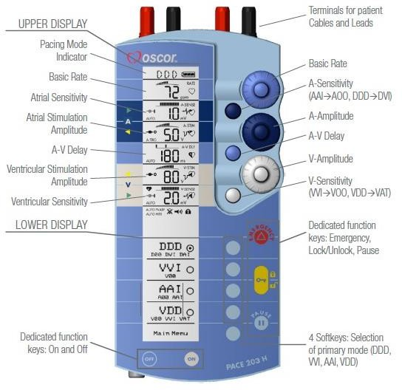
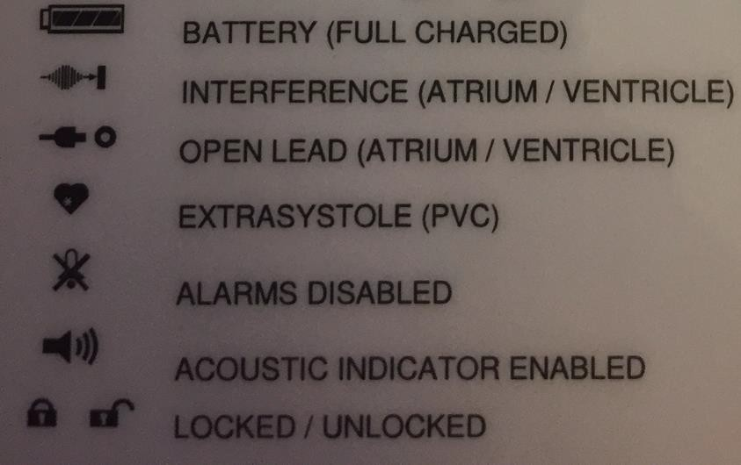

Figure 1: Temporary Pacing Box (above) and the pacing box symbols (below)

Using the Osypka Pace203H Dual Chamber Temporary Pacing Box
The Osypka Pace203H Dual Chamber Temporary Pacing Box is used in Harefield Hospital. Below is a quick guide to its use.

Turning on, allowing changes and turning off
  - To switch the pacing box on, press the white on button and then press the yellow unlock button.
  - Pacing setting can now be changed as required.
  - To turn off, make sure the box is unlocked, press the blue off button and then select either Off (no storage) or Stand by (Store data)
    - ‘Off’ will wipe all settings – use when no the box is longer required.
    - ‘Stand by’ will store current settings and revert the device back to them when switched back on.

Changing the Battery
  - Open the battery port on the back of the pacing box by pressing the white button indicated ‘Press to Open’.
  - Remove the old battery. You now have 30 seconds to change the battery.
  - Insert the new battery with the ports showing the same direction as shown in the diagram on the back of the box.
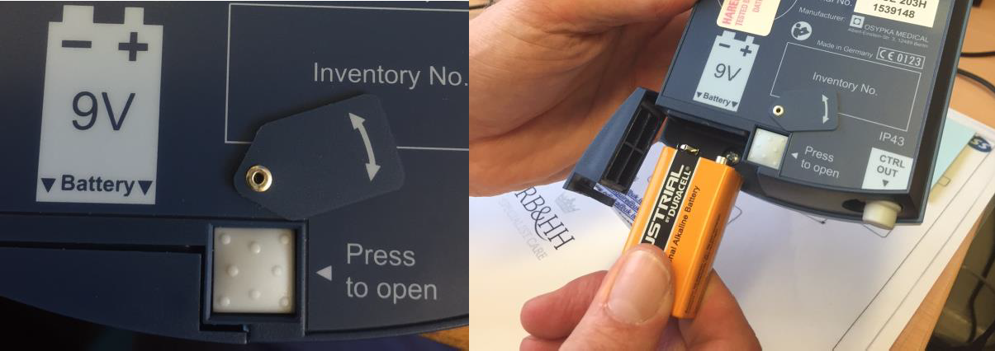
  - Close the battery release hatch. The box should now continue working as before

Figure 2: Changing TPW box battery Changing settings
  - Changing the rate
    - Unlock the pacing box using the yellow unlock button
    - To increase the rate, turn the rate dial clockwise until the display shows the require rate
    - To decrease the rate, turn the rate dial counter clockwise until the display shows the required rate
  - Changing the mode
    - Unlock the pacing box using the yellow unlock button
    - Select the mode by pressing the corresponding button on the mode menu.
    - To select a more unusual mode decrease the relevant chamber sensitivity until the display shows* --. This will change the mode as required

Mode | Action required to change mode
DOO | Decrease both atrial and ventricular sensitivity
DVI | Decrease atrial sensitivity
DAI | Decrease ventricular sensitivity
VOO | Decrease ventricular sensitivity
AOO | Decrease atrial sensitivity

Note: Trigger modes (AAT and VAT) should not be used within the trust unless in conjunction with a cardiologist.

  - Changing the sensitivity
    - Unlock the pacing box using the yellow unlock button
    - To increase the sensitivity, turn the sensitivity dial counter clockwise until the desired sensitivity is displayed on the screen.
    - To decrease the sensitivity, turn the sensitivity dial clockwise until the desired sensitivity is displayed on the screen.
  - Changing the output
    - Unlock the pacing box using the yellow unlock button
    - To increase the output, turn the output dial counter clockwise until the desired output is displayed on the screen.
    - The device will then display a battery drain calculation in mA. Confirm the selected output by pressing the button adjacent to the OK request.
    - To decrease the output, turn the output dial clockwise until the desired output is displayed on the screen.
    - The device will then display a battery drain calculation in mA. Confirm the selected output by pressing the button adjacent to the OK request.
  - Changing the AV delay
    - Unlock the pacing box using the yellow unlock button
    - The auto AV delay is set on all devices to 200ms.
    - To decrease AV delay, rotate the AV delay dial counter clockwise until the Auto AV delay deselects. Continue the counter clockwise turn until the desired AV delay is displayed on the screen.
    - To increase AV delay, rotate the AV delay dial clockwise until the Auto AV delay deselects. Continue the clockwise turn until the desired AV delay is displayed on the screen.
  - Changing the Pulse Duration
    - The pulse duration is auto set to 1.0ms on atrial lead and 0.75ms on ventricular leads.
    - Unlock the pacing box using the yellow unlock button.
    - Press the button adjacent to Main Menu.
    - Press the button adjacent to Parameters and Options.
    - Press the button adjacent to Pulse Duration.
    - To increase the Atrial pulse duration, press the button adjacent to the ↑ in the A column
    - To increase the Ventricular pulse duration, press the button adjacent to the ↑ in the V column
    - To decrease the Atrial pulse duration, press the button adjacent to the ↓ in the A column
    - To decrease the Ventricular pulse duration, press the button adjacent to the ↓ in the V column
  - Performing testing
    - Underlying rhythm and Sensitivity measurements
    - Select an appropriate mode so as to properly assess intrinsic amplitude

    - Reduce rate until intrinsic rhythm breaks through the paced rhythm
      - Do not reduce rate below 40bpm
    - Record patients underlying rhythm and rate in the notes
      - In patients with no underlying rhythm, record as ‘Still pacing at 40bpm’
    - Monitor patient’s arterial line tracing for evidence of destabilisation at low rates. Where no tracing is available, assess patients general well-being as low rates
      - If a patients becomes unstable as the rate is dropped, record this on report as ‘ Patient became unstable at lower rates’
    - Decrease sensitivity until chamber being tested no longer senses intrinsic rhythm.
    - Return sensitivity immediately to a number half of the measured intrinsic amplitude.
    - Record measured intrinsic amplitude and set sensitivity in the patients notes
  - Threshold testing
    - Select an appropriate mode so as to properly assess threshold
    - Set rate to one that over rides any underlying rhythm and completely paces the patients
    - If available, assess BP using Arterial line tracing to assess for de-stabilisation due to single chamber pacing. If not available, assess patients general well- being whilst being paced
    - Decrease output until loss of capture seen on the ECG for the lead being paced.
      - Do not take threshold below 2.5v
    - Return to an output double that of the measured threshold
      - If still capturing at 2.5v, set output to 5v and record threshold as <2.5v

Other Important Trust Protocols
Be aware there are a number of other protocols which will be useful for reference during your placement, these include:
- Recovery Unit Guide
- Pre-assessment of the Lung Transplant Patient
- Pre-assessment of the Thoracic Patient

Contributors
The original Handbook was written by Sarah Williamson, Education Fellow 2019-20, and Nisha Bhudia, Critical Care pharmacist, Harefield Hospital.

We hope you will find this introduction useful and that you enjoy your time here in Harefield Hospital Department of Anaesthesia and Critical Care.

If you would like to help up-date this Handbook in the future, please contact the Medical Education Team, Alex Rosenberg (FICM Tutor) or Ben Silverman (RCoA Tutor).

